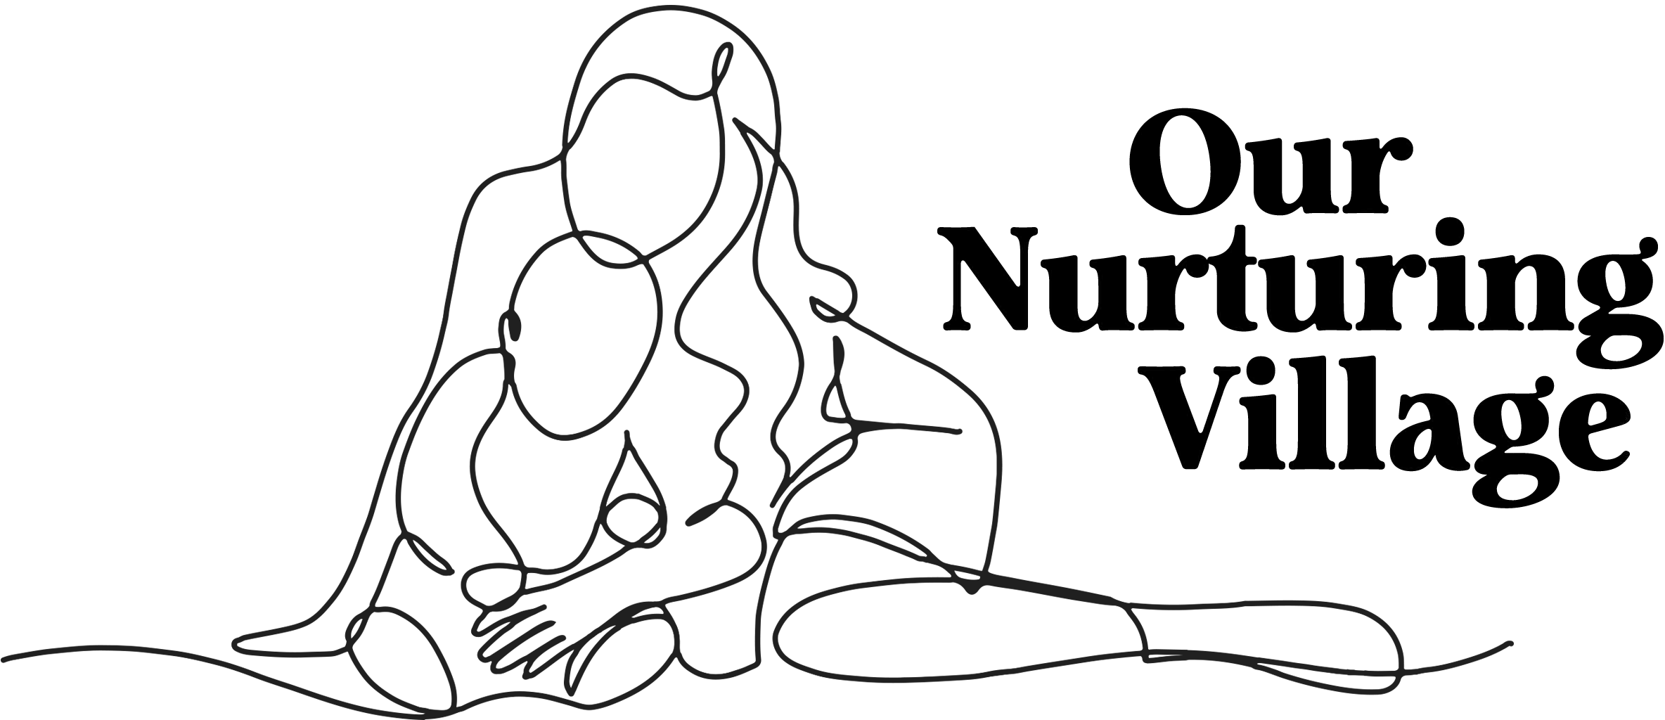

Our Nurturing Village LLC
Closure Days
2026

MLK Jr. Day ~ Monday January 19, 2026

Presidents Day~ Monday February 16, 2026

Mini Spring Break~ May 21-22, 2026

Memorial Day~ May 25, 2026

Juneteenth~ Friday June 19, 2026

Independence Day~ July 3, 2026

Mini Summer Break~ July 15-17, 2026

Labor Day~ Monday September 7, 2026

Indigenous Peoples Day~ Monday October 12, 2026

Veteran’s Day~ Wednesday November 11, 2026

Thanksgiving Day Break~ Wednesday-Friday November 25-27, 2026

Winter Break~ Friday- Monday December 18- January 4, 2027

