Our Nurturing Village LLC
Learning Units

Objective: To create a safe environment for our students to explore, develop, and grow individually as well as collectively.

Neighborhood Field trips:

Daily visits to the playground (across the street)
Storytime at Spark Social (Tuesdays)
Visiting Mission Bay Library
Snack time at Spark Social
Bubbles at Koret Quad
Playing Soccer in the Field
Sight Seeing at Crane Cove
Nature walks through Mission Creek
Little Bears Music Class at Chase Center (Fridays)

Reading:
Abby’s Pink Party, Never touch a porcupine, Eric Carle’s Book of Things, Bluey Activity book, A is for Awesome, I love Earth, You are my Shamrock, Baby Says, Five Clever Mice, Spot Loves School, You’re my little Lucky Charm, 8 Little Planets, Honey Bunny Funnybunny, Young Gifted, and Black, Sleep.

Circle Time:
Wheels on the Bus, ABC song, Row Row Row Your Boat, Head Shoulders Knees & Toes, Down by The Bay, Number Sings, Baba Black Sheep, Itsy Bitsy Spider, Senor Hamlet’s Happy Land Album, Songs from Gracie’s Corner, Songs from Coco Melon, Twinkle Twinkle Little Star, Old McDonald had a Farm.
Fine Motor Activities:
Circle time Velcro Activity, Manipulative puzzles, Sorting with Tweezers, Magnet Tiles, Block Play, Shape Sorter, Sensory Tubes, Lego Flower Builder, Exploring with Zippers, Exploring with Markers, Sand explorations, Exploring with magnet wands/letters, Color sorting, Fishing activity.
Language: Learning Sign Language
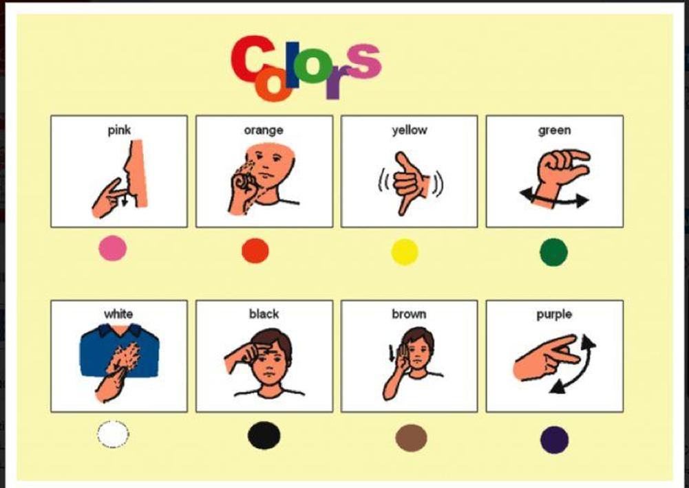

Gross Motor Activities: Yoga, Outdoor activities (walks, Park/Playground), Trash Time, Going to get packages/check mail, Visiting friend
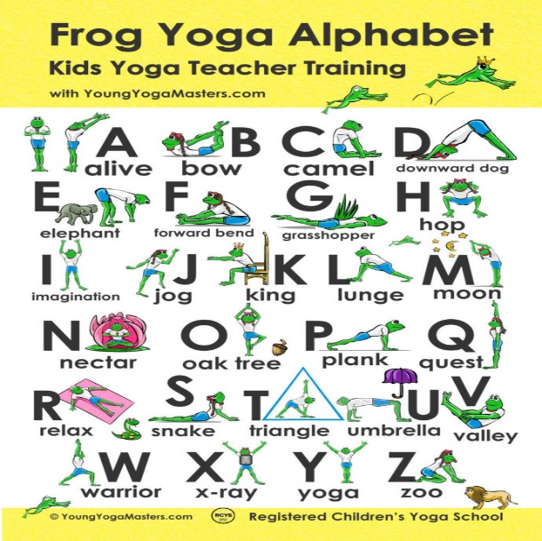

Sensory Activities:
Finger painting, Edible Paint activity, Jell-O Dig, Ice Escape, Sink or Float Activity, Water Tower Activity, Yogurt & Food Color mixing activity, Puff Ball Velcro Activity, Ball Art, Muffin making, Cooking making, Making icy pops, Making our own snacks.

Activities you can try at home:
75 Simple Mess free Toddler Activities To Do At Home With 2, 3 & 4 Year Old (busybloomingjoy.com)
Toddler Information:
Toddler Parenting - HealthyChildren.org

